**Mathematics Specialist Unit 1**

# Investigation 2

**Trigonometric Functions**



**Weigthing 5% Due Date: _____________________**

The concepts and skills included in this investigation relate to the following dot points within the WA Mathematics Specialist syllabus:

**The basic trigonometric functions:**

2.1.1 determine all solutions of f[a(x−b)]=c where 𝑓 is one of sine, cosine or tangent

2.1.2 graph functions with rules of the form y=f(a(x−b))+c where f is one of sine, cosine or tangent.

2.1.9 model periodic motion using sine and cosine functions and understand the relevance of the period and amplitude of these functions in the model.

Part A

The data in the table below shows the monthly average temperatures (oC) at an Australian airport from 2012 to 2014.

|  |  |  |  |  |  |  |  |  |  |  |  |  |
| --- | --- | --- | --- | --- | --- | --- | --- | --- | --- | --- | --- | --- |
|  | **Jan** | **Feb** | **Mar** | **Apr** | **May** | **Jun** | **Jul** | **Aug** | **Sep** | **Oct** | **Nov** | **Dec** |
| 2012 | 33.6 | 32.5 | 29.5 | 28.1 | 24.3 | 19.1 | 18 | 19.1 | 18.7 | 24.2 | 27.4 | 32 |
| 2013 | 35 | 33.1 | 31.1 | 25.7 | 22.2 | 19.3 | 18.3 | 19.5 | 22.1 | 25.1 | 30.3 | 30.5 |
| 2014 | 33.7 | 34.9 | 32.8 | 27.9 | 23.6 | 19.7 | 18.4 | 20.2 | 20.5 | 24.4 | 26.1 | 30.6 |

Draw a graph for the data and describe the pattern.

Determine the trigonometric function that best models the data in the graph and table.

Use the rule you have developed to predict the monthly average temperature for March 2015 and justify your prediction.

Part B

You need to investigate one of the following explain how it can be modelled using a trigonometric function.

* Displacement of a pendulum
* The height of the tide
* Sound waves
* Average temperatures over time
* Hours of daylight
* Height of a blade of a fan
* Something of your choice with periodic motion

**The format of the investigation report must be a typed report, but hand written calculations can be embeded into the document. A maximum of 3 pages. Reports should be submitted electronically via Connect.**

**The report should include the following:**

an outline of the problem and context (Clarifying the Problem)

the method or strategy required to investigate the problem (Choosing and Using Appropriate Mathematics and justifying the choices)

the application of the mathematical model or strategy, including

* relevant data, information and considerations
* mathematical calculations and results, using appropriate representations
* the analysis and interpretation of results, including consideration of the reasonableness and limitations of the results
* the results and conclusions in the context of the problem.
* a short bibliography (including websites) if applicable

Marking Key – Part A (11 marks)

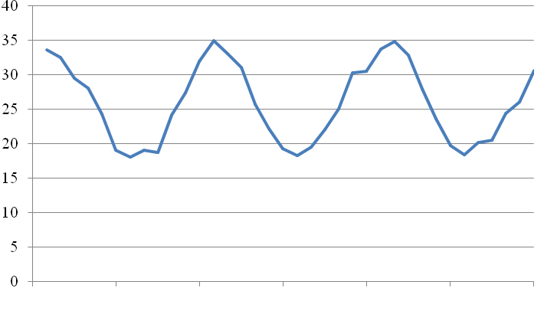

2012 2013 2014

|  |  |  |  |  |  |  |  |  |  |  |
| --- | --- | --- | --- | --- | --- | --- | --- | --- | --- | --- |
|  | | Solution | | | Marking key/mathematical behaviours | | | Marks | | |
|  | | Graph | | | Label axes  Plotted points  Trig graph plotted | | | 1  1  1 | | |
| (a) | |  | | | * Determines four correct coefficients and constants * Selects appropriate trigonometric function | | | 4  1 | | |
|  | | Solution | | Marking key/mathematical behaviours | | | | Marks | | |
| (b) | |  | | | * Chooses correct *x* value * Calculates the correct temperature * Identifies a method to check | | 1  1  1 | | |

Part B ( 28 marks)

|  |  |  |
| --- | --- | --- |
|  |  |  |
| Clarifying the Problem | Introduction outlining the task | 1 |
| Choosing and using Appropriate Mathematics and justifying the choices | Explanation of how to tackle task  Data going to use  Why?  Assumptions | 2  1  1  1 |
| Application | Graph  Variables defined  Points plotted  Domain and Range  Appropriate Trig function  Correct coefficients  Explanation for equation  Trig function drawn  Reasonableness of solution  Limitations of the model  Correct units used  Set out in a logical way showing steps of the working | 1  1  1  1  1  4  2  1  1  2  1  2 |
| Results and Conclusion | Relates function to original problem  Conclusion | 2  1 |
| Bibliography included |  | 1 |